Hastalipi
A multi-media presentation on manuscripts from the North-East

Selected rare and illustrated manuscripts from various parts of the North-East, mainly from the states of Arunachal Pradesh, Assam, Manipur and Sikkim have been exhibited both digitally and in the original (or prints) in the “Purvottari” the Spirit of Northeast event at the IGNCA during 10th -18th January, 2009. These textual resources are on various aspects of life and culture of the people of North-East, which throw light on the Spirit of the North-East.

The data includes the manuscripts like Chitra Bhagawata, Ramayana, Mahabharata, Bhaswati, Kalki Puran, Gita Govinda, Hari Vamsa, Kirttan, Nam Ghosh, Guru Padma ‘byung gnas kyi skyes rabs rnam par thar pa zhes bya ba (Padma bka’ thang), Vessantara Jataka, Leisemlon Laiharaoba, Cheithabas, Kangla Nunglon etc. covering subjects like history, astronomy, astrology, genealogy, mathematics, geography, religious discourses, literature, natural and human resource management strategies, food, medicine, tantra, martial art etc. Most of the manuscripts are written in 17th and 18th Century. These are mainly in Assamese, Sanskrit, Tai-Khampti, Tibetan and Manipuri languages, written in Kaitheli, Bamunia, Lahkari, Meitei, Khampti, Bengali scripts. Some of these texts have been composed by scholars like Shankaradeva, Madhavadeva, Madhav Kandali, Ram Saraswati, Raghunath Mahanta etc. Materials used for these manuscripts are mainly Sanchipat and Handmade paper. Natural vegetable colours were used for writing these manuscripts.

Six workstations were installed for the display of digital manuscripts in the gallery. These manuscripts can be searched on computer by title, author, subject, language, script, illustration, state and repository and then every page of the manuscript can be seen page by page as per the user’s choice.

Above manuscripts are mainly form the Namgyal Institute of Tibetology (Sikkim), Manipur State Kala Academy (Manipur), Atombapu Research Centre (Manipur), Mutua Museum (Manipur), Manipur State Archives (Manipur), Kamarupa Anusandhan Samiti (Guwahati, Assam), Srimant Sankaradeva Kalakshetra (Guwahati, Assam), Ujani Kangshapar Sattra (Molankata, Raha, Nagaon, Assam) and Jarabari Sattra (Jhanji, Sivasagar, Assam) and personal collection of Dr. Naren Kalita (Assam), Shri Bimal Goswami (Assam) etc.

The Indira Gandhi National Centre for the Arts (IGNCA), in collaboration with the Srimanta Sankaradeva Kalakshetra, already digitized over 10000 manuscripts in Assam (including many Sattra in Majuli), about 2400 manuscripts in Manipur. Continuing its activity the IGNCA will digitize remaining manuscripts in the North-East India in coming years.
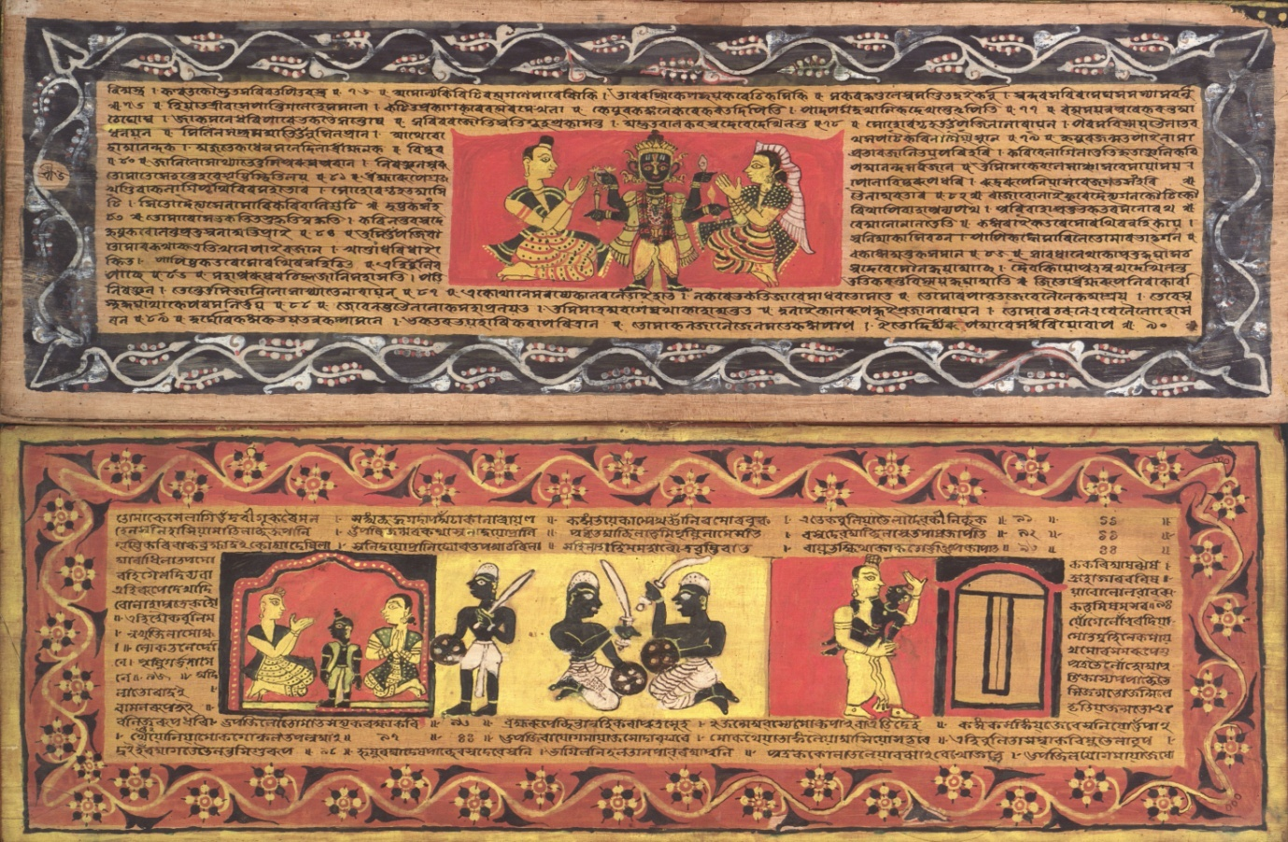
Chitra Bhagawata, Assamese

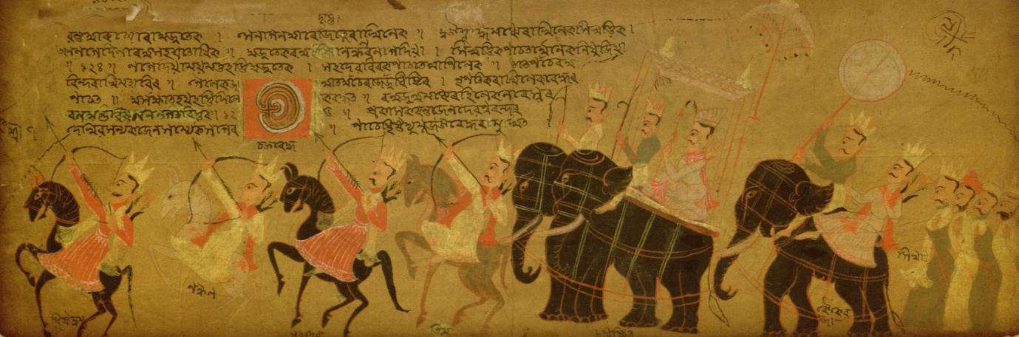
Mahabharata Karna Parba, Assamese

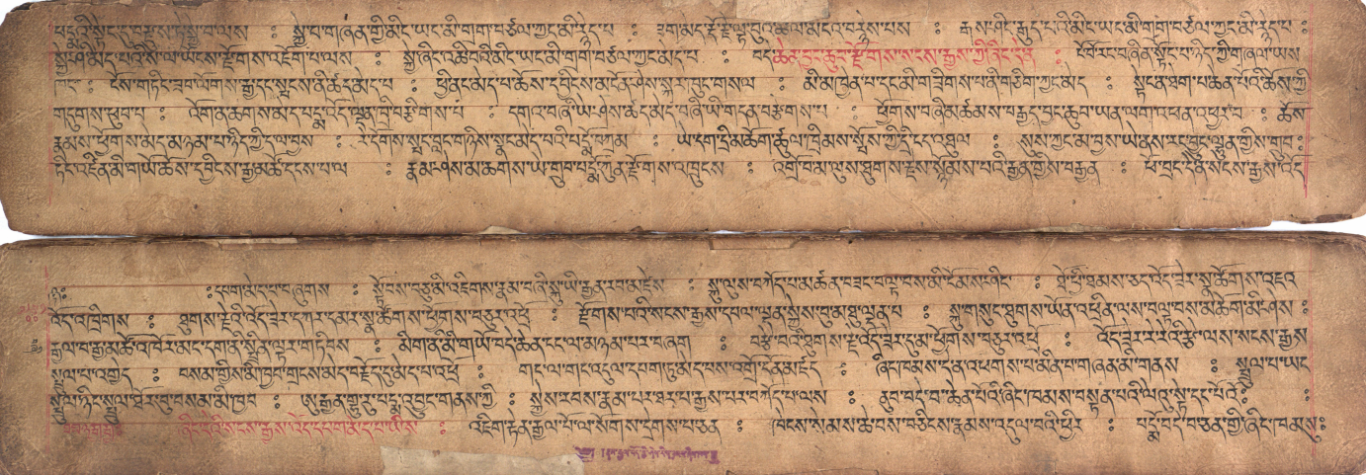Guru Padma ‘byung gnas kyi skyes rabs rnam par thar pa zhes bya ba (Padma bka’ thang), Tibetan

