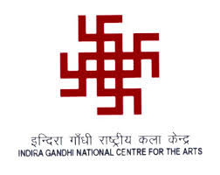
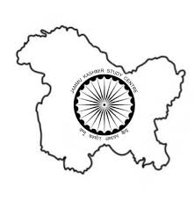

Indira Gandhi National Centre for the Arts
In collaboration with
Jammu Kashmir Study Centre, New Delhi

Announces
11-days Workshop on the Śāradā Script

Starting from 13th November 2017
Venue: IGNCA, New Delhi

Registration Form

Name:

Date of Birth:

Education Qualifications:
S.N | Qualification | University | Year | Percentage of Marks | Subject

Affiliated to University/Institution:

Address:

Email:

Mobile no:

Basic knowledge of Śāradā Script: Yes/No

Basic knowledge of Sanskrit: Yes/No

Signature:

